Beef Data - Final Analysis

Michael Streyle, Carly Mester, Matt Foundos

November 5, 2017

# Set global figure size  
#knitr::opts_chunk$set(fig.width=6, fig.height=3.5)   
  
  
beef <- read.table('http://ww2.amstat.org/publications/jse/v22n1/kopcso/BeefDemand.txt', header = TRUE)  
  
  
attach(beef)  
#creating a new variable called myRealDPI because there is an error in X.RDPI.Mean..sq  
myRealDPIsq=(RealDPI-mean(RealDPI))^2

boxplot(ChickPrice, main="Chicken Price")

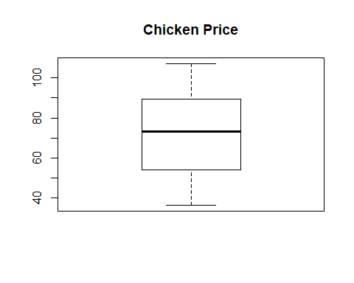

boxplot(BeefPrice, main="Beef Price")

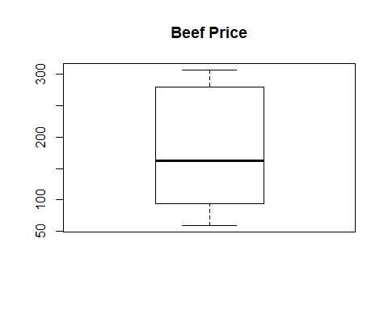

boxplot(BeefConsump, main="Beef Consumption", ylab='pounds')

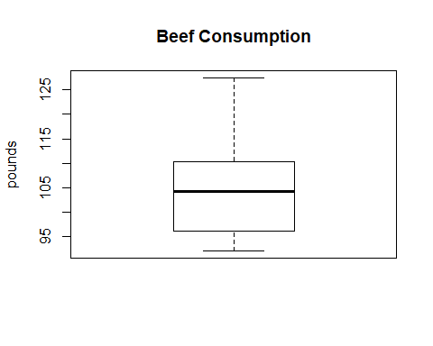

boxplot(log(BeefConsump), main=" LOG Beef Consumption", ylab='pounds')

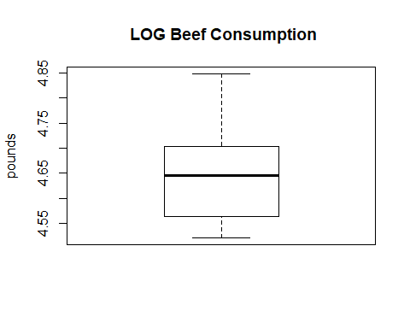

boxplot(CPI, main="CPI")

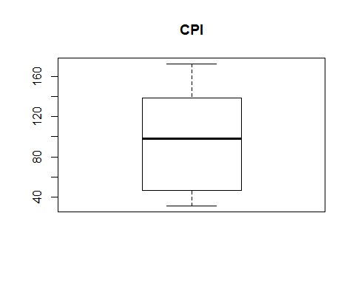

boxplot(DPI, main="DPI")

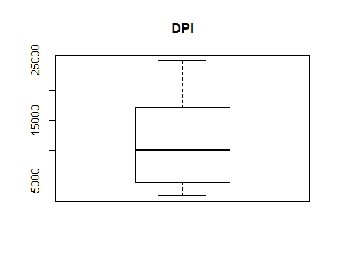

boxplot(RealChickenPrice, main="Real Chicken Price")

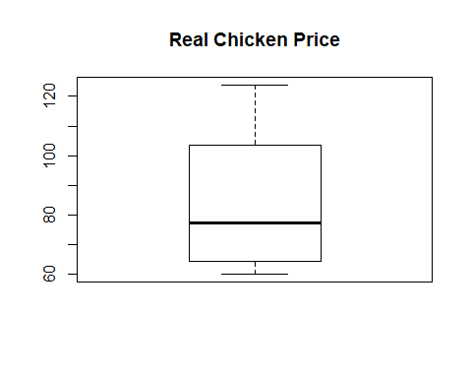

boxplot(RealBeefPrice, main="Real Beef Price")

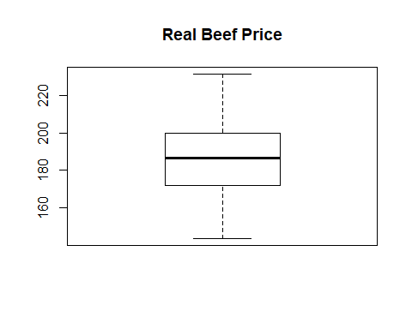

boxplot(RealDPI, main="Real DPI")

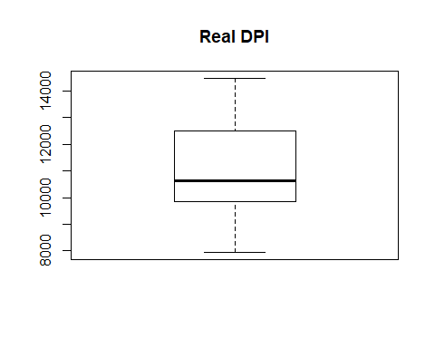

boxplot(myRealDPIsq, main="Real DPI-Squared")

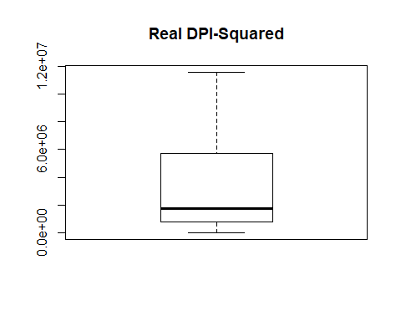

round (cor(beef), 2)

## Year ChickPrice BeefPrice BeefConsump CPI DPI  
## Year 1.00 0.98 0.96 -0.69 0.99 0.99  
## ChickPrice 0.98 1.00 0.94 -0.67 0.97 0.96  
## BeefPrice 0.96 0.94 1.00 -0.79 0.97 0.96  
## BeefConsump -0.69 -0.67 -0.79 1.00 -0.76 -0.76  
## CPI 0.99 0.97 0.97 -0.76 1.00 0.99  
## DPI 0.99 0.96 0.96 -0.76 0.99 1.00  
## RealChickenPrice -0.94 -0.90 -0.91 0.71 -0.95 -0.91  
## RealBeefPrice -0.11 -0.11 0.12 -0.17 -0.12 -0.10  
## RealDPI 0.98 0.96 0.95 -0.66 0.97 0.98  
## X.RDPI.Mean..sq 0.97 0.95 0.94 -0.67 0.96 0.98  
## RealChickenPrice RealBeefPrice RealDPI X.RDPI.Mean..sq  
## Year -0.94 -0.11 0.98 0.97  
## ChickPrice -0.90 -0.11 0.96 0.95  
## BeefPrice -0.91 0.12 0.95 0.94  
## BeefConsump 0.71 -0.17 -0.66 -0.67  
## CPI -0.95 -0.12 0.97 0.96  
## DPI -0.91 -0.10 0.98 0.98  
## RealChickenPrice 1.00 0.21 -0.87 -0.86  
## RealBeefPrice 0.21 1.00 -0.04 -0.04  
## RealDPI -0.87 -0.04 1.00 1.00  
## X.RDPI.Mean..sq -0.86 -0.04 1.00 1.00

pairs(beef)

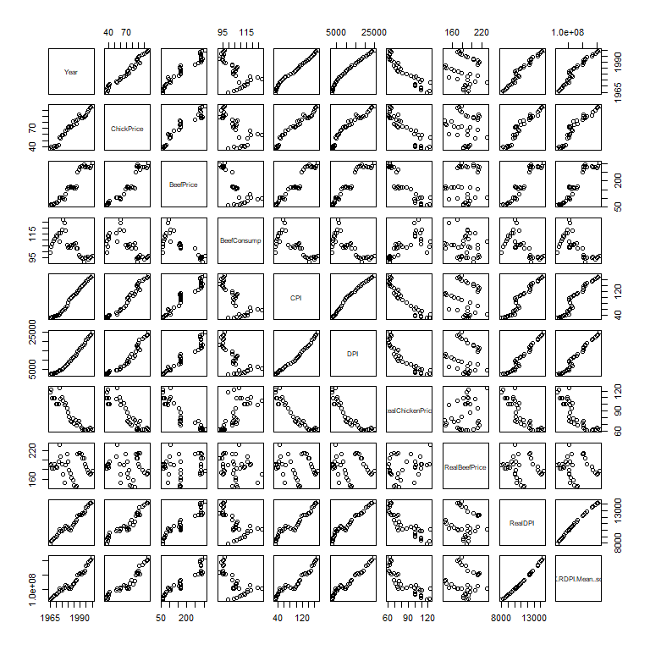

#fit a model with all variables   
myfit1 <- lm(BeefConsump ~ Year + ChickPrice + BeefPrice + CPI + DPI + RealChickenPrice + RealBeefPrice + RealDPI + myRealDPIsq)  
plot(myfit1)

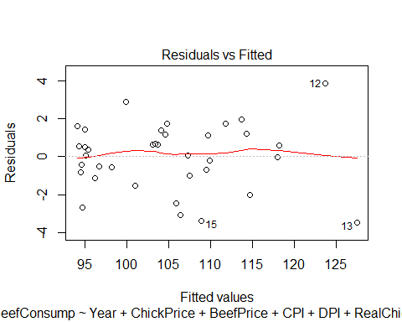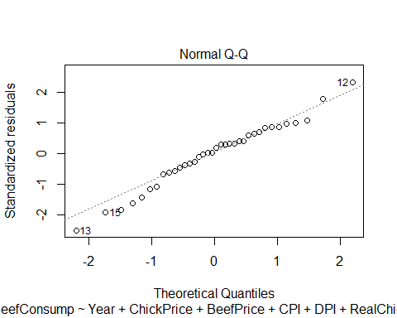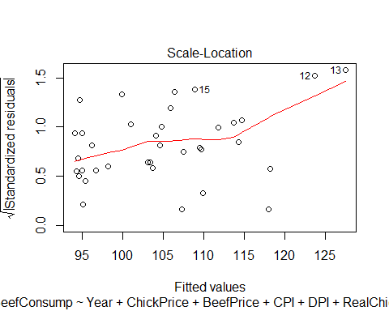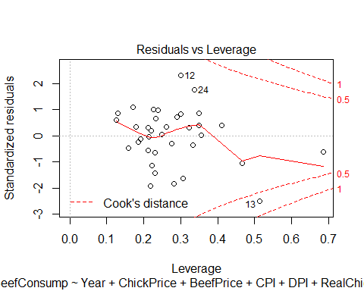

summary(myfit1)

##   
## Call:  
## lm(formula = BeefConsump ~ Year + ChickPrice + BeefPrice + CPI +   
## DPI + RealChickenPrice + RealBeefPrice + RealDPI + myRealDPIsq)  
##   
## Residuals:  
## Min 1Q Median 3Q Max   
## -3.4656 -0.8820 0.2151 1.1653 3.8570   
##   
## Coefficients:  
## Estimate Std. Error t value Pr(>|t|)   
## (Intercept) -9.695e+03 1.863e+03 -5.205 1.96e-05 ***  
## Year 5.010e+00 9.437e-01 5.308 1.49e-05 ***  
## ChickPrice -1.783e-01 2.162e-01 -0.825 0.4171   
## BeefPrice 2.854e-01 5.810e-02 4.912 4.24e-05 ***  
## CPI -1.035e+00 6.892e-01 -1.501 0.1453   
## DPI -4.834e-03 6.016e-03 -0.804 0.4289   
## RealChickenPrice 2.390e-01 1.355e-01 1.764 0.0895 .   
## RealBeefPrice -4.116e-01 6.128e-02 -6.716 3.99e-07 ***  
## RealDPI 3.299e-03 6.629e-03 0.498 0.6229   
## myRealDPIsq 1.005e-06 1.208e-06 0.832 0.4130   
## ---  
## Signif. codes: 0 '***' 0.001 '**' 0.01 '*' 0.05 '.' 0.1 ' ' 1  
##   
## Residual standard error: 1.989 on 26 degrees of freedom  
## Multiple R-squared: 0.9644, Adjusted R-squared: 0.952   
## F-statistic: 78.16 on 9 and 26 DF, p-value: < 2.2e-16

anova(myfit1)

## Analysis of Variance Table  
##   
## Response: BeefConsump  
## Df Sum Sq Mean Sq F value Pr(>F)   
## Year 1 1386.17 1386.17 350.4102 < 2.2e-16 ***  
## ChickPrice 1 12.25 12.25 3.0957 0.09027 .   
## BeefPrice 1 615.57 615.57 155.6117 1.766e-12 ***  
## CPI 1 571.95 571.95 144.5842 4.008e-12 ***  
## DPI 1 12.24 12.24 3.0931 0.09039 .   
## RealChickenPrice 1 4.02 4.02 1.0170 0.32251   
## RealBeefPrice 1 176.66 176.66 44.6580 4.333e-07 ***  
## RealDPI 1 1.25 1.25 0.3157 0.57904   
## myRealDPIsq 1 2.74 2.74 0.6922 0.41299   
## Residuals 26 102.85 3.96   
## ---  
## Signif. codes: 0 '***' 0.001 '**' 0.01 '*' 0.05 '.' 0.1 ' ' 1

boxplot(myfit1$residuals)

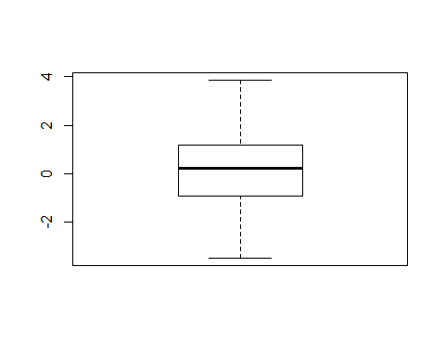

qqnorm(myfit1$residuals)  
qqline(myfit1$residuals)

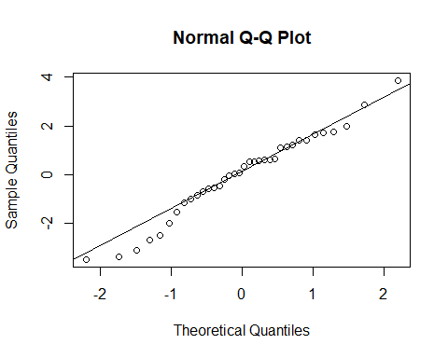

## Interaction Effects

#creating a function to center a variable  
my.center = function (x) (x - mean (x))  
  
detach(beef)  
  
#centering our three significant variables from our first order model. Year, BeefPrice, and RealBeefPrice, and CPI since it is significant in our myFit4  
beef$Year.c = my.center (beef$Year)  
beef$BeefPrice.c = my.center (beef$BeefPrice)  
beef$RealBeefPrice.c = my.center (beef$RealBeefPrice)  
beef$CPI.c = my.center (beef$CPI)  
  
  
attach(beef)  
  
beef$Year.BeefPrice = Year.c * BeefPrice.c  
beef$Year.RealBeefPrice = Year.c * RealBeefPrice.c  
beef$Year.CPI = Year.c * CPI.c  
  
beef$BeefPrice.RealBeefPrice = BeefPrice.c * RealBeefPrice.c  
beef$BeefPrice.CPI = BeefPrice.c * CPI.c  
  
beef$RealBeefPrice.CPI = RealBeefPrice.c * CPI.c  
  
detach(beef)  
attach(beef)  
  
#fit a model with the primary predictors and their interactions  
#then do a backward elimination  
  
fit.int = lm(BeefConsump ~ Year.c + BeefPrice.c + RealBeefPrice.c + CPI.c + Year.BeefPrice + Year.RealBeefPrice + Year.CPI + BeefPrice.RealBeefPrice + BeefPrice.CPI + RealBeefPrice.CPI)  
  
summary(fit.int)

##   
## Call:  
## lm(formula = BeefConsump ~ Year.c + BeefPrice.c + RealBeefPrice.c +   
## CPI.c + Year.BeefPrice + Year.RealBeefPrice + Year.CPI +   
## BeefPrice.RealBeefPrice + BeefPrice.CPI + RealBeefPrice.CPI)  
##   
## Residuals:  
## Min 1Q Median 3Q Max   
## -3.5213 -0.7809 0.1750 1.1316 4.7943   
##   
## Coefficients: (1 not defined because of singularities)  
## Estimate Std. Error t value Pr(>|t|)   
## (Intercept) 105.089928 0.909330 115.569 < 2e-16 ***  
## Year.c 5.399060 1.032955 5.227 1.85e-05 ***  
## BeefPrice.c 0.256187 0.738985 0.347 0.732   
## RealBeefPrice.c -0.441598 0.685710 -0.644 0.525   
## CPI.c -1.816713 1.359463 -1.336 0.193   
## Year.BeefPrice 0.033251 0.023263 1.429 0.165   
## Year.RealBeefPrice -0.003906 0.035975 -0.109 0.914   
## Year.CPI -0.039994 0.025888 -1.545 0.134   
## BeefPrice.RealBeefPrice -0.001780 0.001040 -1.711 0.099 .   
## BeefPrice.CPI -0.002482 0.002426 -1.023 0.316   
## RealBeefPrice.CPI NA NA NA NA   
## ---  
## Signif. codes: 0 '***' 0.001 '**' 0.01 '*' 0.05 '.' 0.1 ' ' 1  
##   
## Residual standard error: 2.025 on 26 degrees of freedom  
## Multiple R-squared: 0.9631, Adjusted R-squared: 0.9503   
## F-statistic: 75.34 on 9 and 26 DF, p-value: 2.488e-16

n=36  
step.int = step (fit.int, direction = "both", k=log(n))

## Start: AIC=74.91  
## BeefConsump ~ Year.c + BeefPrice.c + RealBeefPrice.c + CPI.c +   
## Year.BeefPrice + Year.RealBeefPrice + Year.CPI + BeefPrice.RealBeefPrice +   
## BeefPrice.CPI + RealBeefPrice.CPI  
##   
##   
## Step: AIC=74.91  
## BeefConsump ~ Year.c + BeefPrice.c + RealBeefPrice.c + CPI.c +   
## Year.BeefPrice + Year.RealBeefPrice + Year.CPI + BeefPrice.RealBeefPrice +   
## BeefPrice.CPI  
##   
## Df Sum of Sq RSS AIC  
## - Year.RealBeefPrice 1 0.048 106.62 71.339  
## - BeefPrice.c 1 0.493 107.06 71.488  
## - RealBeefPrice.c 1 1.700 108.27 71.892  
## - BeefPrice.CPI 1 4.290 110.86 72.743  
## - CPI.c 1 7.320 113.89 73.714  
## - Year.BeefPrice 1 8.374 114.95 74.046  
## - Year.CPI 1 9.783 116.35 74.484  
## <none> 106.57 74.906  
## - BeefPrice.RealBeefPrice 1 11.995 118.57 75.162  
## - Year.c 1 111.980 218.55 97.178  
##   
## Step: AIC=71.34  
## BeefConsump ~ Year.c + BeefPrice.c + RealBeefPrice.c + CPI.c +   
## Year.BeefPrice + Year.CPI + BeefPrice.RealBeefPrice + BeefPrice.CPI  
##   
## Df Sum of Sq RSS AIC  
## - BeefPrice.c 1 3.130 109.75 68.797  
## - BeefPrice.CPI 1 4.244 110.86 69.161  
## - Year.BeefPrice 1 8.431 115.05 70.495  
## - Year.CPI 1 10.190 116.81 71.041  
## <none> 106.62 71.339  
## - BeefPrice.RealBeefPrice 1 13.059 119.68 71.915  
## - RealBeefPrice.c 1 18.518 125.14 73.520  
## + Year.RealBeefPrice 1 0.048 106.57 74.906  
## - CPI.c 1 93.217 199.84 90.372  
## - Year.c 1 111.979 218.60 93.602  
##   
## Step: AIC=68.8  
## BeefConsump ~ Year.c + RealBeefPrice.c + CPI.c + Year.BeefPrice +   
## Year.CPI + BeefPrice.RealBeefPrice + BeefPrice.CPI  
##   
## Df Sum of Sq RSS AIC  
## - BeefPrice.CPI 1 7.964 117.71 67.735  
## - BeefPrice.RealBeefPrice 1 10.489 120.24 68.499  
## <none> 109.75 68.797  
## + BeefPrice.c 1 3.130 106.62 71.339  
## + RealBeefPrice.CPI 1 3.130 106.62 71.339  
## + Year.RealBeefPrice 1 2.686 107.06 71.488  
## - Year.BeefPrice 1 21.537 131.29 71.664  
## - Year.CPI 1 30.516 140.27 74.045  
## - Year.c 1 154.121 263.87 96.795  
## - RealBeefPrice.c 1 164.127 273.88 98.134  
## - CPI.c 1 203.489 313.24 102.969  
##   
## Step: AIC=67.74  
## BeefConsump ~ Year.c + RealBeefPrice.c + CPI.c + Year.BeefPrice +   
## Year.CPI + BeefPrice.RealBeefPrice  
##   
## Df Sum of Sq RSS AIC  
## - BeefPrice.RealBeefPrice 1 3.79 121.50 65.293  
## <none> 117.71 67.735  
## + BeefPrice.CPI 1 7.96 109.75 68.797  
## + BeefPrice.c 1 6.85 110.86 69.161  
## + RealBeefPrice.CPI 1 6.85 110.86 69.161  
## + Year.RealBeefPrice 1 6.32 111.40 69.334  
## - Year.CPI 1 25.07 142.79 71.104  
## - Year.BeefPrice 1 27.26 144.97 71.649  
## - RealBeefPrice.c 1 178.61 296.32 97.387  
## - Year.c 1 736.25 853.96 135.490  
## - CPI.c 1 962.21 1079.93 143.942  
##   
## Step: AIC=65.29  
## BeefConsump ~ Year.c + RealBeefPrice.c + CPI.c + Year.BeefPrice +   
## Year.CPI  
##   
## Df Sum of Sq RSS AIC  
## <none> 121.50 65.293  
## + BeefPrice.RealBeefPrice 1 3.79 117.71 67.735  
## + Year.RealBeefPrice 1 2.10 119.40 68.248  
## + RealBeefPrice.CPI 1 1.53 119.98 68.421  
## + BeefPrice.c 1 1.53 119.98 68.421  
## + BeefPrice.CPI 1 1.27 120.24 68.499  
## - Year.BeefPrice 1 76.90 198.40 79.362  
## - Year.CPI 1 79.96 201.46 79.913  
## - RealBeefPrice.c 1 309.09 430.59 107.257  
## - Year.c 1 742.31 863.82 132.320  
## - CPI.c 1 963.97 1085.47 140.543

summary(step.int)

##   
## Call:  
## lm(formula = BeefConsump ~ Year.c + RealBeefPrice.c + CPI.c +   
## Year.BeefPrice + Year.CPI)  
##   
## Residuals:  
## Min 1Q Median 3Q Max   
## -3.8797 -0.9471 0.0948 1.2222 5.2434   
##   
## Coefficients:  
## Estimate Std. Error t value Pr(>|t|)   
## (Intercept) 104.086415 0.613353 169.701 < 2e-16 ***  
## Year.c 4.486867 0.331425 13.538 2.59e-14 ***  
## RealBeefPrice.c -0.173964 0.019914 -8.736 9.65e-10 ***  
## CPI.c -1.152199 0.074685 -15.427 8.29e-16 ***  
## Year.BeefPrice 0.012659 0.002905 4.357 0.000142 ***  
## Year.CPI -0.021400 0.004816 -4.443 0.000112 ***  
## ---  
## Signif. codes: 0 '***' 0.001 '**' 0.01 '*' 0.05 '.' 0.1 ' ' 1  
##   
## Residual standard error: 2.013 on 30 degrees of freedom  
## Multiple R-squared: 0.9579, Adjusted R-squared: 0.9509   
## F-statistic: 136.5 on 5 and 30 DF, p-value: < 2.2e-16

The stepwise procedure ended with the following model: BeefConsump ~ Year.c + RealBeefPrice.c + CPI.c + Year.BeefPrice + Year.CPI + BeefPrice.RealBeefPrice + BeefPrice.CPI

Our BeefPrice was removed, but three interaction effects involving BeefPrice were kept. We will test this model vs a reduced model where those three interaction effects are removed.

step.int.red = lm(BeefConsump ~ Year.c + RealBeefPrice.c + CPI.c + BeefPrice.c +  
 Year.CPI + Year.BeefPrice)  
summary(step.int.red)

##   
## Call:  
## lm(formula = BeefConsump ~ Year.c + RealBeefPrice.c + CPI.c +   
## BeefPrice.c + Year.CPI + Year.BeefPrice)  
##   
## Residuals:  
## Min 1Q Median 3Q Max   
## -3.7449 -0.7564 0.1299 1.1696 5.1240   
##   
## Coefficients:  
## Estimate Std. Error t value Pr(>|t|)   
## (Intercept) 104.236344 0.667195 156.231 < 2e-16 ***  
## Year.c 4.412263 0.356753 12.368 4.34e-13 ***  
## RealBeefPrice.c -0.254257 0.133651 -1.902 0.0671 .   
## CPI.c -1.323229 0.291387 -4.541 9.06e-05 ***  
## BeefPrice.c 0.100880 0.166004 0.608 0.5481   
## Year.CPI -0.012152 0.015977 -0.761 0.4530   
## Year.BeefPrice 0.007402 0.009136 0.810 0.4244   
## ---  
## Signif. codes: 0 '***' 0.001 '**' 0.01 '*' 0.05 '.' 0.1 ' ' 1  
##   
## Residual standard error: 2.034 on 29 degrees of freedom  
## Multiple R-squared: 0.9584, Adjusted R-squared: 0.9498   
## F-statistic: 111.4 on 6 and 29 DF, p-value: < 2.2e-16

anova(step.int.red, step.int)

## Analysis of Variance Table  
##   
## Model 1: BeefConsump ~ Year.c + RealBeefPrice.c + CPI.c + BeefPrice.c +   
## Year.CPI + Year.BeefPrice  
## Model 2: BeefConsump ~ Year.c + RealBeefPrice.c + CPI.c + Year.BeefPrice +   
## Year.CPI  
## Res.Df RSS Df Sum of Sq F Pr(>F)  
## 1 29 119.98   
## 2 30 121.50 -1 -1.5278 0.3693 0.5481

The full step-wise model fits better than the reduced model. The difference between models has a p-value of 0.0007566. While it is a very small p-value, neither of these models fits as well as our myfit4.

par (mfrow = c(1, 2))  
plot (step.int.red, main="Stepwise w/Interactions")

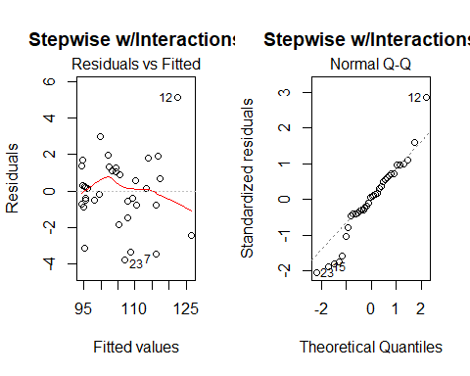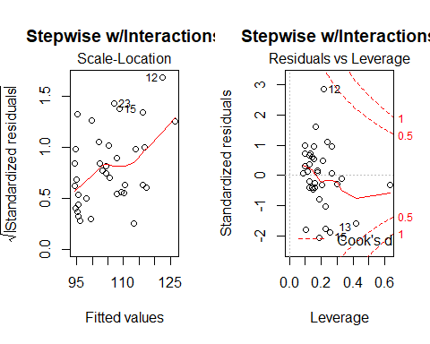

plot (step.int.red$fitted.values, BeefConsump, main="BeefConsump vs Fitted",  
 xlab = "Fitted BeefConsump", ylab = "BeefConsump")  
abline(0, 1)

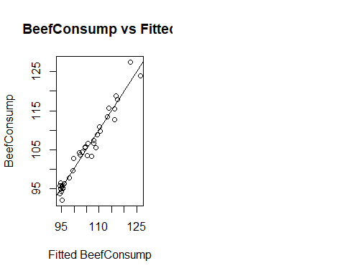 The residuals vs fitted looks pretty good. There is little evidence of outliers, non-constant variance, or significant curvature. The Q-Q plot also looks pretty good. All points are pretty close to the line, indicating that a normal distribution is a reasonable assumption for these residuals.

#fit a model with all variables and interactions(2)  
myfit5 <- lm(BeefConsump ~ Year + ChickPrice + BeefPrice + CPI + DPI + RealChickenPrice + RealBeefPrice + RealDPI + myRealDPIsq + BeefPrice.RealBeefPrice + Year.CPI)  
plot(myfit5)

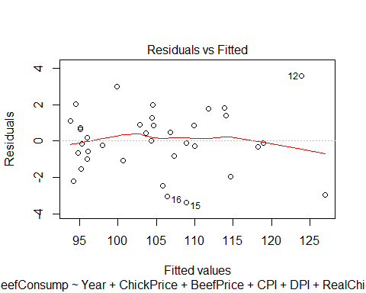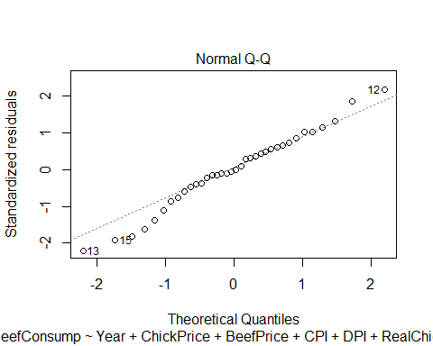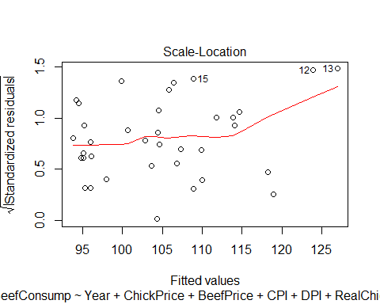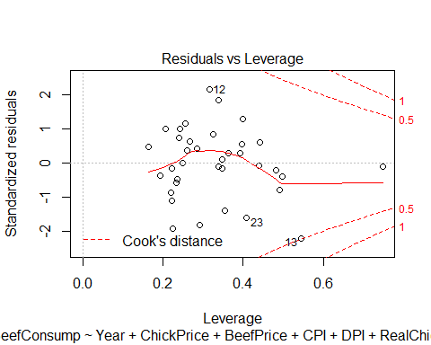

summary(myfit5)

##   
## Call:  
## lm(formula = BeefConsump ~ Year + ChickPrice + BeefPrice + CPI +   
## DPI + RealChickenPrice + RealBeefPrice + RealDPI + myRealDPIsq +   
## BeefPrice.RealBeefPrice + Year.CPI)  
##   
## Residuals:  
## Min 1Q Median 3Q Max   
## -3.3746 -0.8838 -0.0485 0.9533 3.5685   
##   
## Coefficients:  
## Estimate Std. Error t value Pr(>|t|)   
## (Intercept) -7.906e+03 2.417e+03 -3.271 0.00323 **  
## Year 4.161e+00 1.219e+00 3.415 0.00227 **  
## ChickPrice -2.121e-01 2.591e-01 -0.819 0.42109   
## BeefPrice 4.577e-01 1.959e-01 2.337 0.02812 *   
## CPI -2.272e+00 1.362e+00 -1.668 0.10835   
## DPI 5.127e-03 1.343e-02 0.382 0.70599   
## RealChickenPrice 2.911e-01 1.690e-01 1.722 0.09790 .   
## RealBeefPrice -5.868e-01 1.995e-01 -2.941 0.00714 **  
## RealDPI -5.021e-03 1.376e-02 -0.365 0.71838   
## myRealDPIsq -1.636e-07 1.566e-06 -0.104 0.91764   
## BeefPrice.RealBeefPrice -1.125e-03 1.122e-03 -1.003 0.32602   
## Year.CPI -1.203e-02 1.641e-02 -0.733 0.47052   
## ---  
## Signif. codes: 0 '***' 0.001 '**' 0.01 '*' 0.05 '.' 0.1 ' ' 1  
##   
## Residual standard error: 1.991 on 24 degrees of freedom  
## Multiple R-squared: 0.967, Adjusted R-squared: 0.9519   
## F-statistic: 63.97 on 11 and 24 DF, p-value: 4.923e-15

anova(myfit5)

## Analysis of Variance Table  
##   
## Response: BeefConsump  
## Df Sum Sq Mean Sq F value Pr(>F)   
## Year 1 1386.17 1386.17 349.5535 8.220e-16 ***  
## ChickPrice 1 12.25 12.25 3.0881 0.09162 .   
## BeefPrice 1 615.57 615.57 155.2312 5.722e-12 ***  
## CPI 1 571.95 571.95 144.2307 1.229e-11 ***  
## DPI 1 12.24 12.24 3.0856 0.09174 .   
## RealChickenPrice 1 4.02 4.02 1.0146 0.32386   
## RealBeefPrice 1 176.66 176.66 44.5488 6.650e-07 ***  
## RealDPI 1 1.25 1.25 0.3149 0.57990   
## myRealDPIsq 1 2.74 2.74 0.6905 0.41418   
## BeefPrice.RealBeefPrice 1 5.55 5.55 1.3988 0.24851   
## Year.CPI 1 2.13 2.13 0.5376 0.47052   
## Residuals 24 95.17 3.97   
## ---  
## Signif. codes: 0 '***' 0.001 '**' 0.01 '*' 0.05 '.' 0.1 ' ' 1

boxplot(myfit5$residuals)

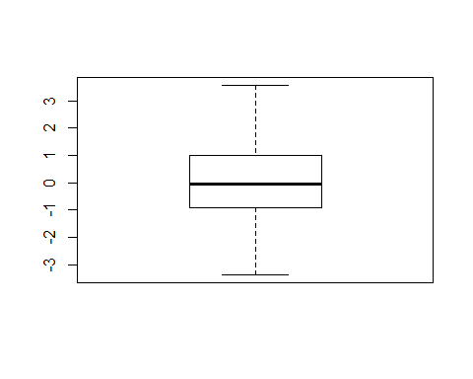

qqnorm(myfit5$residuals)  
qqline(myfit5$residuals)

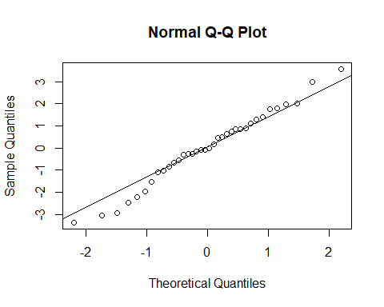 The interactions are not significant and there is no added significance once we add the interactions to our myfit1.

#myfit4 from first draft analysis  
myfit4 <- lm(formula = BeefConsump ~ Year + BeefPrice + CPI + RealChickenPrice +   
 RealBeefPrice)  
plot(myfit4)

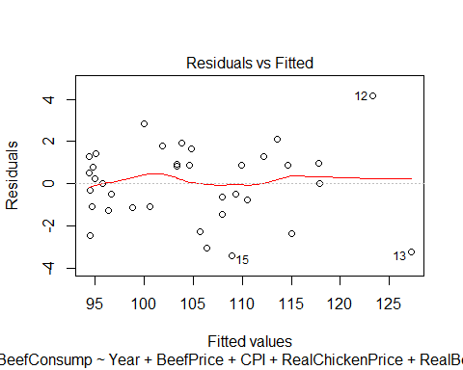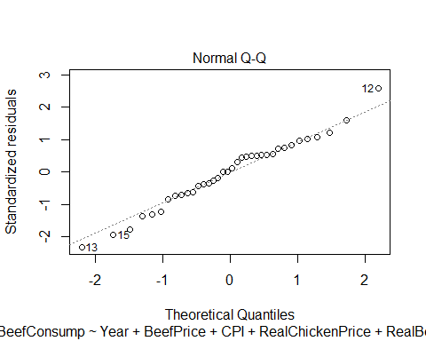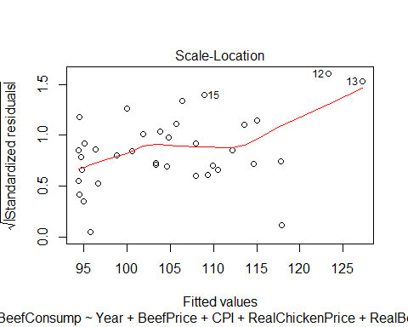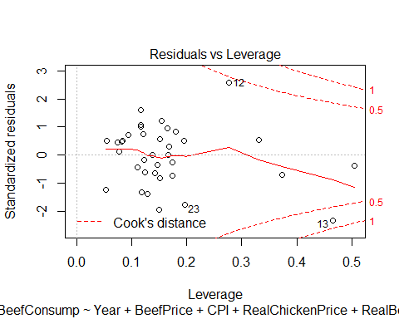

summary(myfit4)

##   
## Call:  
## lm(formula = BeefConsump ~ Year + BeefPrice + CPI + RealChickenPrice +   
## RealBeefPrice)  
##   
## Residuals:  
## Min 1Q Median 3Q Max   
## -3.4016 -1.1130 0.1231 1.0582 4.1643   
##   
## Coefficients:  
## Estimate Std. Error t value Pr(>|t|)   
## (Intercept) -7.956e+03 5.221e+02 -15.236 1.16e-15 ***  
## Year 4.147e+00 2.671e-01 15.525 7.00e-16 ***  
## BeefPrice 2.681e-01 5.279e-02 5.077 1.87e-05 ***  
## CPI -1.521e+00 1.162e-01 -13.095 6.11e-14 ***  
## RealChickenPrice 1.298e-01 5.980e-02 2.170 0.0381 *   
## RealBeefPrice -4.026e-01 5.715e-02 -7.045 7.86e-08 ***  
## ---  
## Signif. codes: 0 '***' 0.001 '**' 0.01 '*' 0.05 '.' 0.1 ' ' 1  
##   
## Residual standard error: 1.899 on 30 degrees of freedom  
## Multiple R-squared: 0.9625, Adjusted R-squared: 0.9563   
## F-statistic: 154.1 on 5 and 30 DF, p-value: < 2.2e-16

par (mfrow = c(1,2))  
library (car)

## Warning: package 'car' was built under R version 3.4.2

avPlots(myfit4)

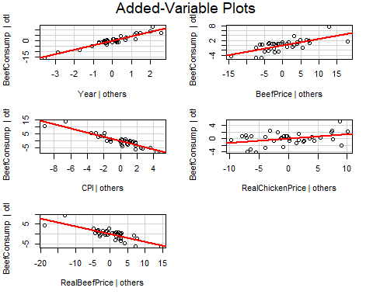

#some predictions using myfit4  
p.myfit4 = predict(myfit4, interval='prediction')

## Warning in predict.lm(myfit4, interval = "prediction"): predictions on current data refer to _future_ responses

round(p.myfit4[c(3:4, 23:24, 27:28)], 3) #myfit4 predicted values

## [1] 107.972 110.481 106.348 99.947 94.333 94.457

round(BeefConsump[c(3:4, 23:24, 27:28)], 3) #actual values

## [1] 106.500 109.700 103.300 102.799 94.856 94.144

p.step.int = predict(step.int, interval='prediction')

## Warning in predict.lm(step.int, interval = "prediction"): predictions on current data refer to _future_ responses

round(p.step.int[c(3:4, 23:24, 27:28)], 3) #step.int predicted values

## [1] 107.816 110.355 107.180 99.562 94.586 95.160

round(BeefConsump[c(3:4, 23:24, 27:28)], 3) #actual values

## [1] 106.500 109.700 103.300 102.799 94.856 94.144

p.step.int.red = predict(step.int.red, interval='prediction')

## Warning in predict.lm(step.int.red, interval = "prediction"): predictions on current data refer to _future_ responses

round(p.step.int.red[c(3:4, 23:24, 27:28)], 3) #step.int.red predicted values

## [1] 107.955 110.460 107.045 99.825 94.556 95.019

round(BeefConsump[c(3:4, 23:24, 27:28)], 3) #actual values

## [1] 106.500 109.700 103.300 102.799 94.856 94.144

x = round(p.step.int[c(3:4, 23:24, 27:28)], 3) - round(BeefConsump[c(3:4, 23:24, 27:28)], 3) #differences between actual and predicted using step.int  
sum(abs(x)) #sum of absolute value of differences between predicted using step.int and actual

## [1] 10.374

z = round(p.myfit4[c(3:4, 23:24, 27:28)], 3) - round(BeefConsump[c(3:4, 23:24, 27:28)], 3) #differences between actual and predicted using myfit4  
sum(abs(z)) #sum of absolute value of differences between predicted using myfit4 and actual values

## [1] 8.989

w = round(p.step.int.red[c(3:4, 23:24, 27:28)], 3) - round(BeefConsump[c(3:4, 23:24, 27:28)], 3) #differences between actual and predicted using step.int.red  
sum(abs(w)) #sum of absolute value of differences between predicted using step.int.red and actual values

## [1] 10.109

Summing the absolute differences between the predictive model and the actual values serves as a way to compare how useful each model is in predicting the response variable. The sum of the differences using step.int is 10.374, the sum of the differences using step.int.red is 10.109, and the sum of the differences using myfit4 is 8.989. This indicates that for predictive purposes, myfit4 is probably the most useful (although all models show strong standard error and R squared values.)